Documentaion Of MLOps Task

1. I download the wights from vgg16 model
2. Then is save the weights in my model as myvgg16.h5

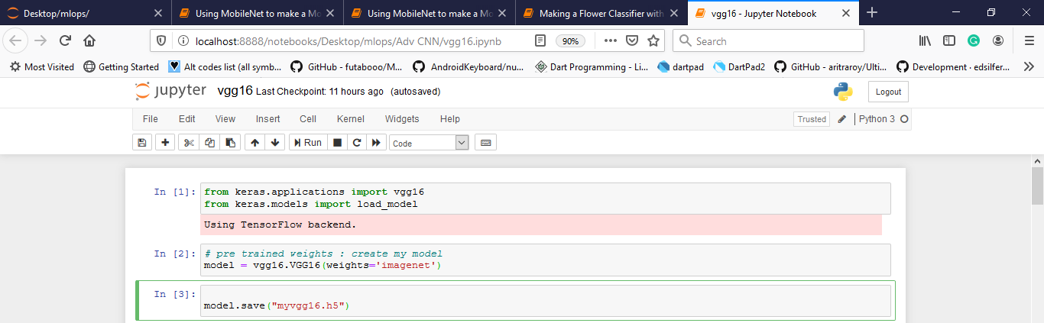

1. I import mobilenet ansd set rows and columns of image to (224,224)
2. Freeze all the layers by using a loop and layers.trainable=False

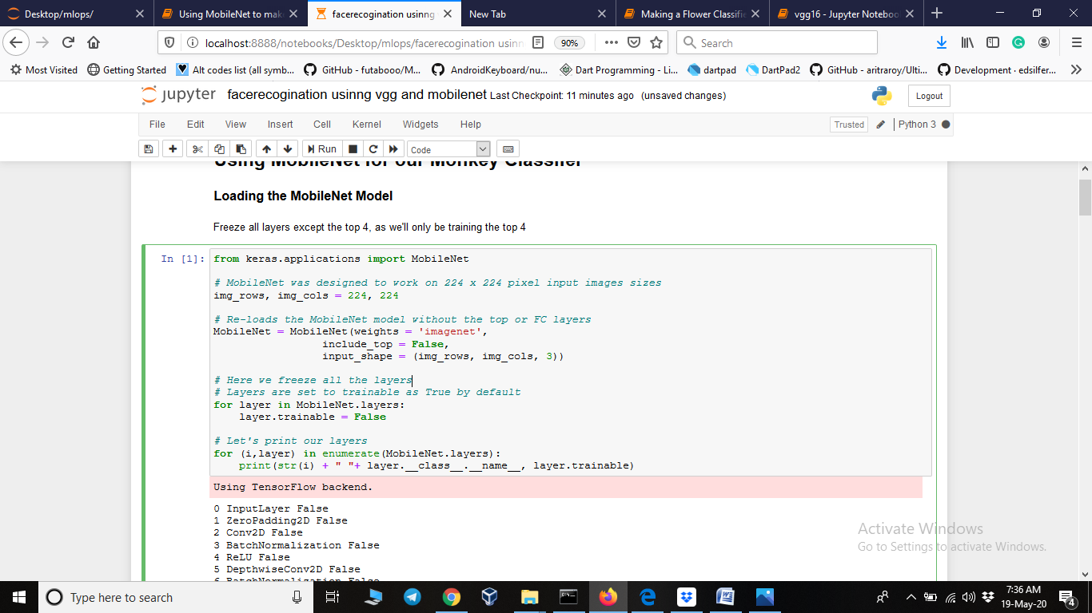

1. Then I checked all the layers name and cross verify all layers are freezed or not

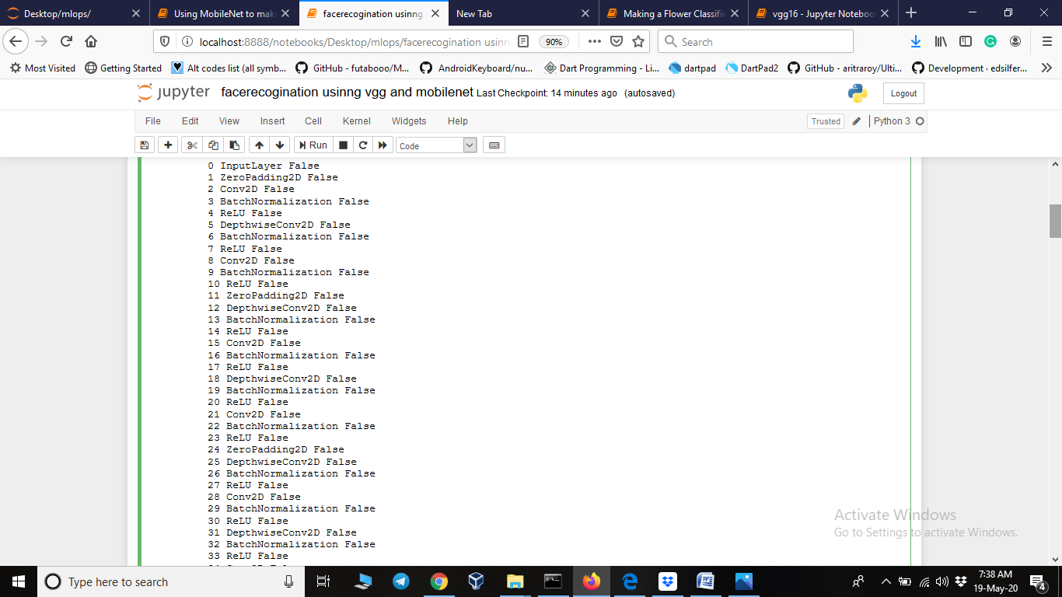

1. Then created a function add_top_model

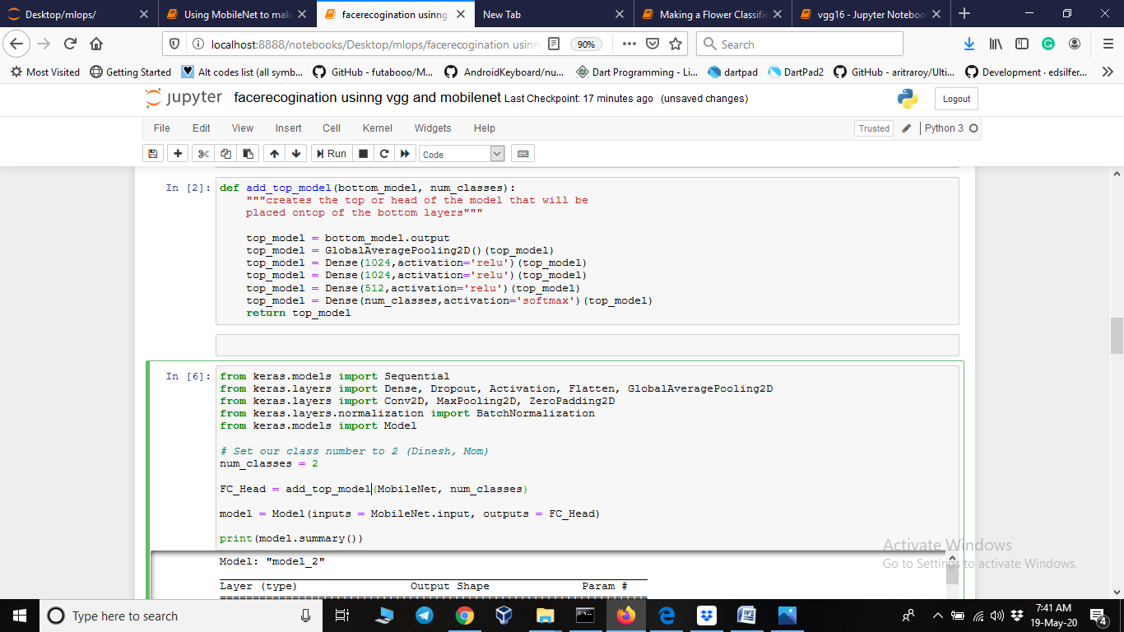

1. Add three more layers in the model
2. Softmax is used as because I am using multi classification
3. Called the function add_top_model and assign retuen value in FC_head
4. Print model summary

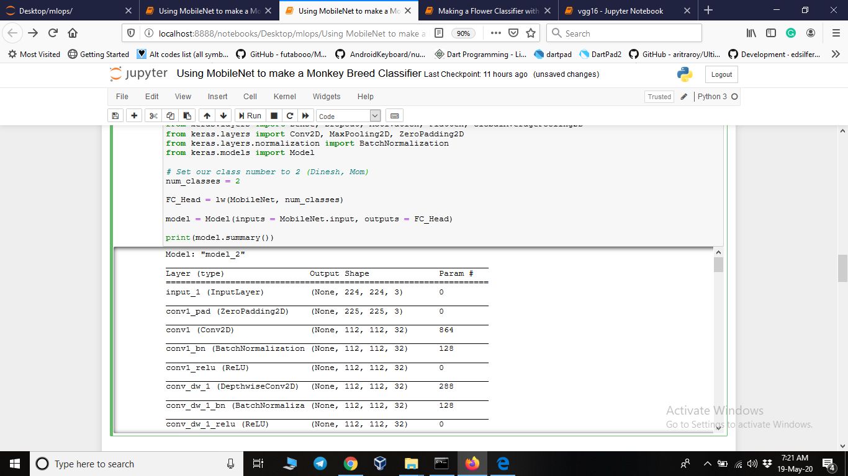

1. Used image generator to make liitle changes in images so they look different

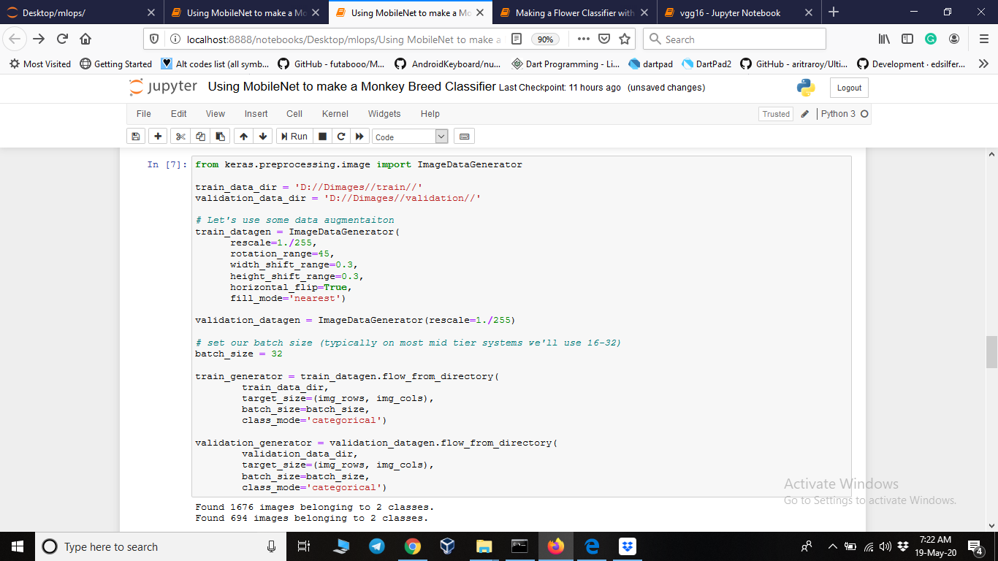

1. Trained the model using 3 epochs and 16 batch size

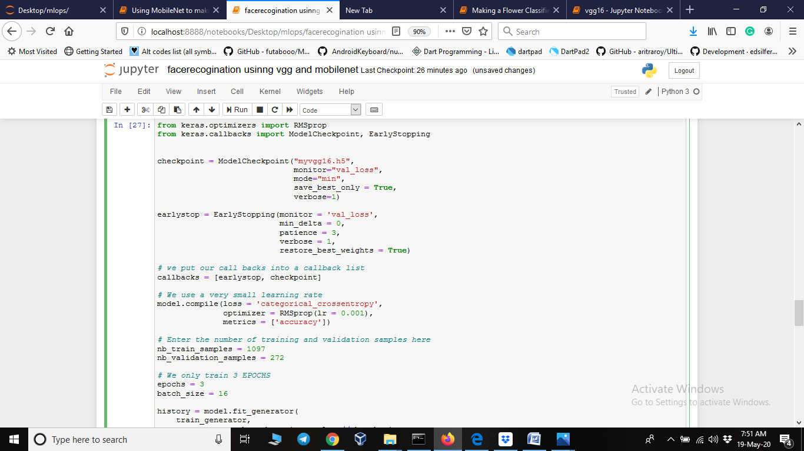

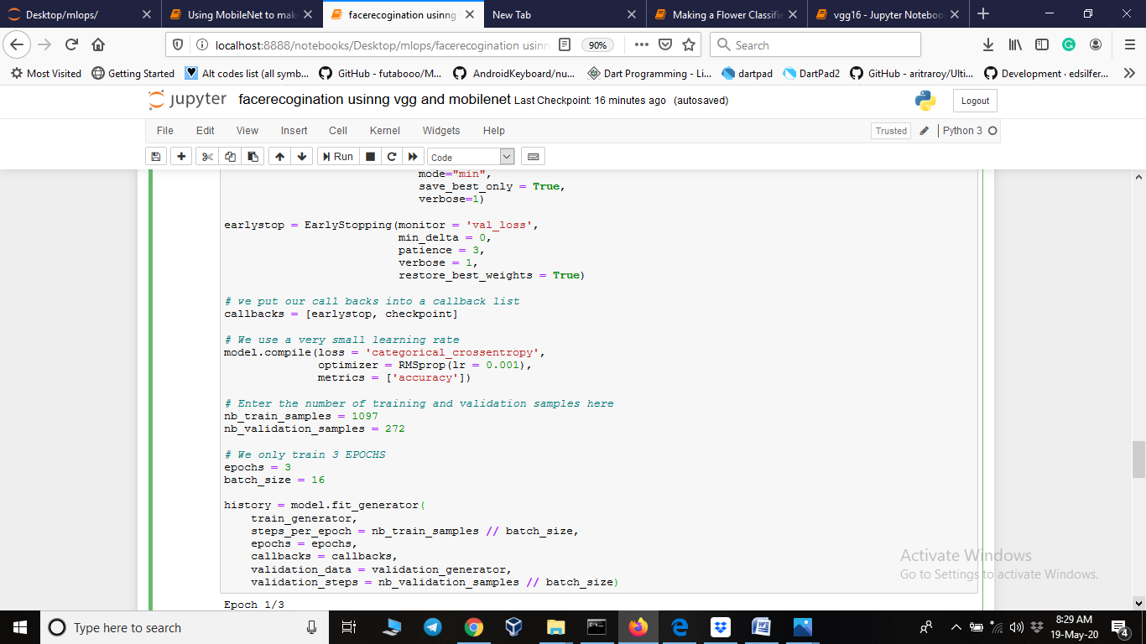

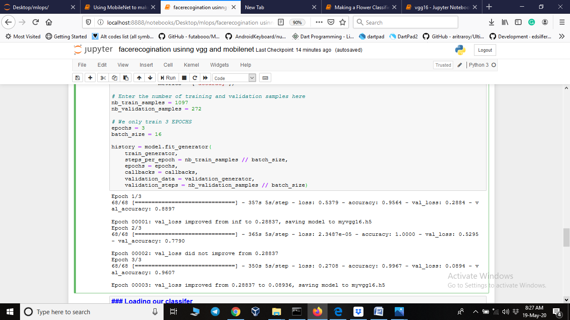

15. save model as vgg16.h5 after 3 epochs

16 . used cv2 to show the image with label as prediction

17. used os,os.path, modules to get path where our data is stored

18. load the newly saved model newvgg16.h5

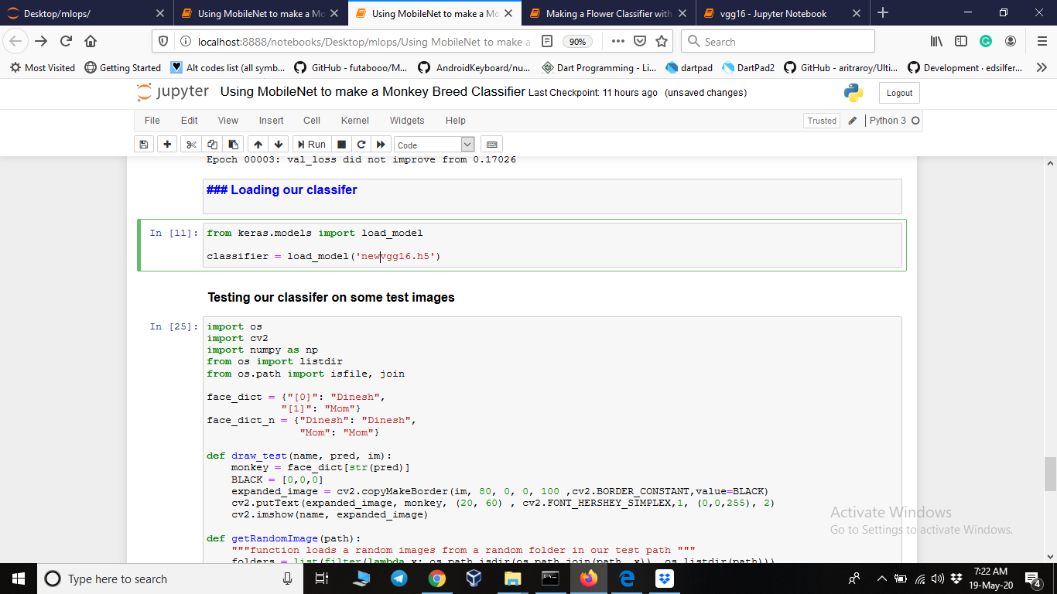

17. from validation folder pick 10 images and predicat the output

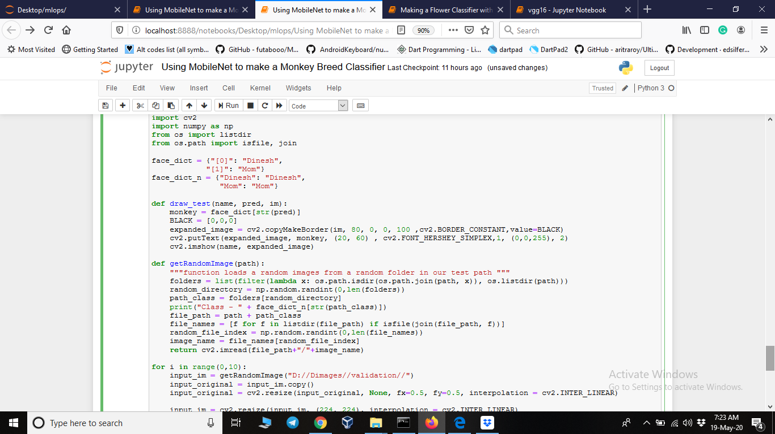

#pridiction 1

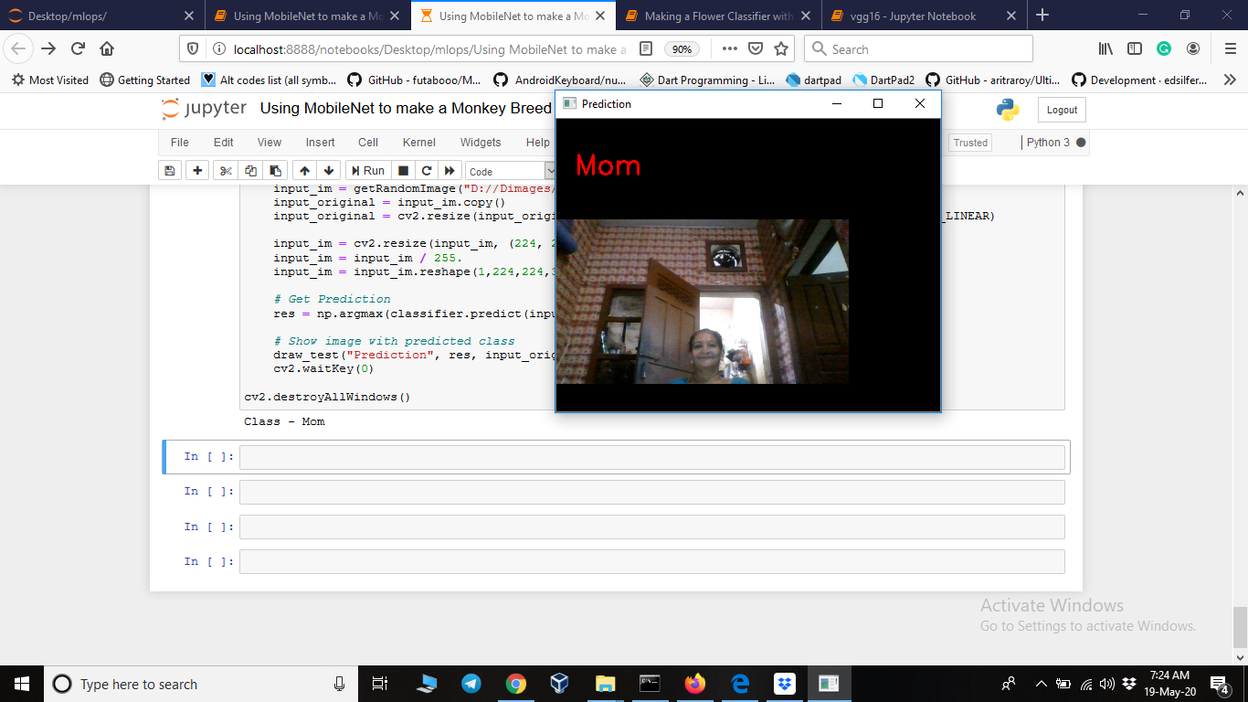

#prediction3

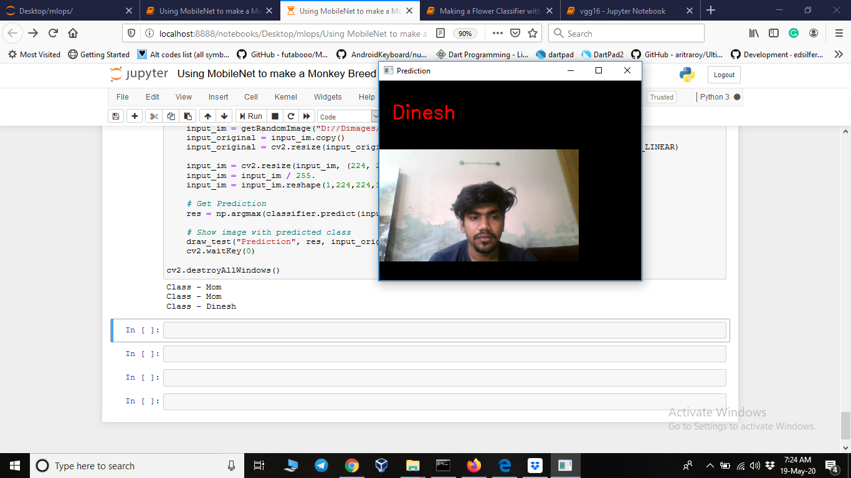

#prediction4

